The Nuts & Bolts of Matter
Integrated Science

Name ___________________________________ Date ___________Pd_____

Objective: Students will classify matter as pure substances or mixtures. Students will demonstrate their understanding through definitions, observations, and flow charts.

Pre-Lab:

1. What are the two criteria for matter?

__________________________________________________________________________

2. What are the two main classes of matter? __________________ & __________________
_
3. What are the two classes of pure substances? _________________ & _______________

4. How are the two classes of pure substances different?

__________________________________________________________________________

__________________________________________________________________________

__________________________________________________________________________

5. How are the two classes of mixtures different?

__________________________________________________________________________

__________________________________________________________________________

__________________________________________________________________________

6. Why aren't compounds mixtures?

__________________________________________________________________________

__________________________________________________________________________

7. Classify each of the following as an element, compound, homogeneous mixture or heterogeneous mixture:

- salt water ____________________

- hydrogen ____________________

- oil and water __________________

- sodium chloride __________________

8. Each of the circles below shows a sample of matter. Put checks in the table to indicate what kind of matter each circle shows. (First decide if pure substance or mixture, then what type of pure substance or mixture. In other words, each sample should have 2 check marks!)

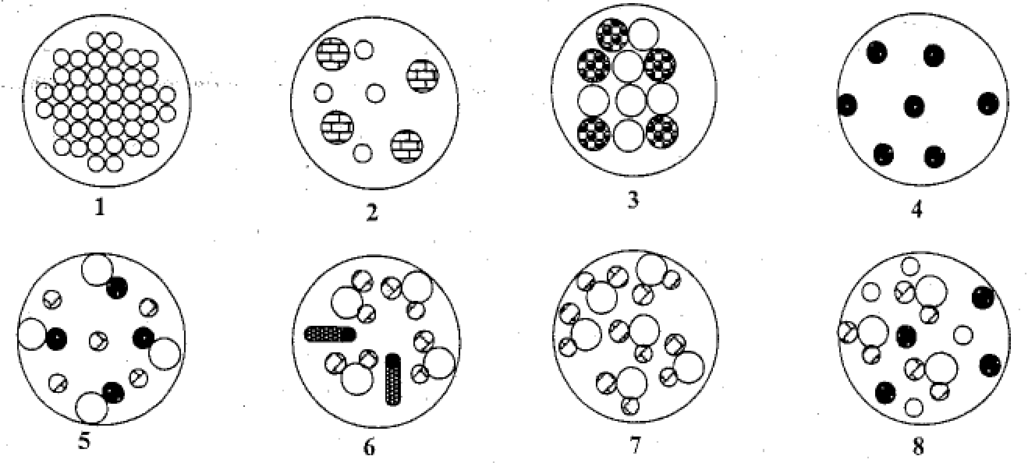

SAMPLES

Classification | 1 | 2 | 3 | 4 | 5 | 6 | 7 | 8
Pure Substance
*element
* compound
Mixture
*heterogeneous
*homogeneous

*You must get teacher check off before continuing: ____________

Lab Background: Bulk samples of an element, a compound, and a mixture may look similar on the outside, but when we discuss what they look like on the inside we need to imagine atoms, compounds, and mixtures. This activity will help you visualize these abstract concepts of atoms, compounds, and mixtures in relation to the classification of matter.

Procedures:
1. Obtain a set of sealed Petri dishes labeled A-J. (Again you will have to share sets so do not take all of the samples at once.
2. For each sample, sketch what it looks like in the circles below. Be sure to include any descriptions that will help you classify.

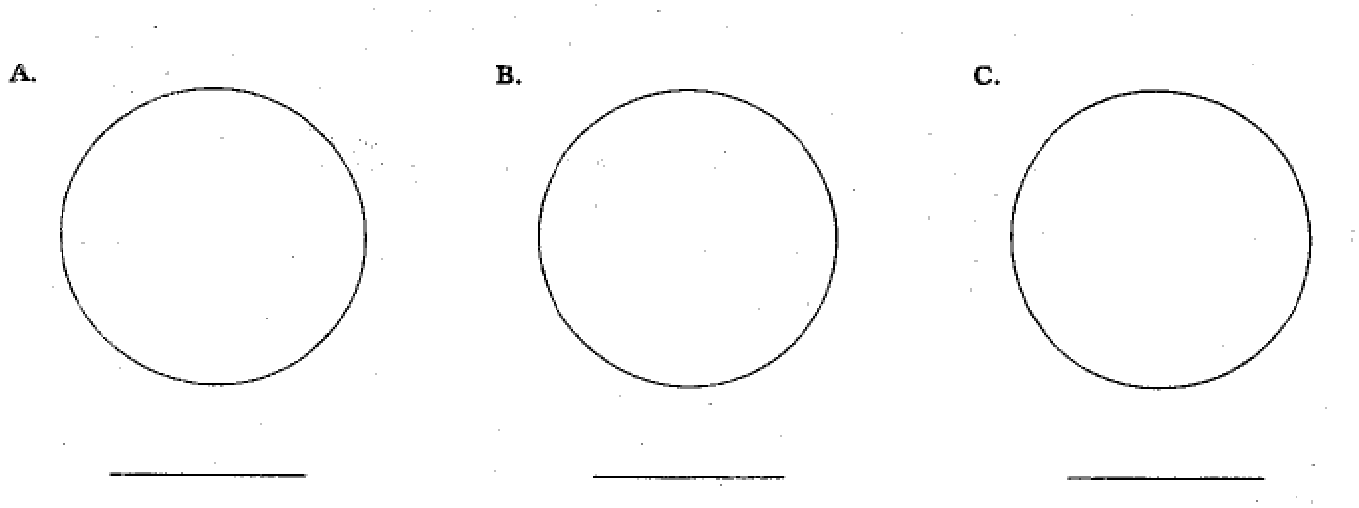

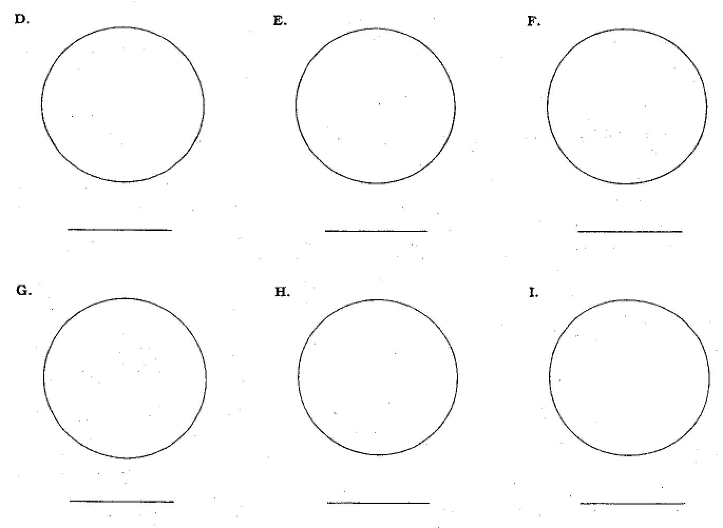

3. Us your descriptions and sketches to help you classify the samples. Put checks in the table to indicate what kind of matter each circle shows. (First decide if pure substance or mixture, then what type of pure substance or mixture. In other words, each sample should have 2 check marks!)

SAMPLES

Classification | A | B | C | D | E | F | G | H | I | J
Pure Substance
*element
* compound
Mixture
*heterogeneous
*homogeneous

